**Create a React Application named “cricketapp” with the following components:**

1. **ListofPlayers**
2. **IndianPlayers**

npx create-react-app cricketapp

cd cricketapp

ListofPlayers.js

import React from 'react';

const ListofPlayers = () => {

  const players = [

    { name: 'Virat Kohli', score: 98 },

    { name: 'Rohit Sharma', score: 45 },

    { name: 'KL Rahul', score: 72 },

    { name: 'Shreyas Iyer', score: 65 },

    { name: 'Hardik Pandya', score: 89 },

    { name: 'Rishabh Pant', score: 55 },

    { name: 'Ravindra Jadeja', score: 76 },

    { name: 'Jasprit Bumrah', score: 60 },

    { name: 'Mohammed Shami', score: 70 },

    { name: 'Suryakumar Yadav', score: 68 },

    { name: 'Shubman Gill', score: 80 },

  ];

  const filteredPlayers = players.filter(player => player.score >= 70);

  return (

    <div>

      <h2>List of Players (Score >= 70)</h2>

      <ul>

        {filteredPlayers.map((player, index) => (

          <li key={index}>{player.name} - {player.score}</li>

        ))}

      </ul>

    </div>

  );

};

export default ListofPlayers;

IndianPlayers.js

import React from 'react';

const IndianPlayers = () => {

  const T20players = ['Virat', 'Rohit', 'Pant', 'Hardik', 'Bumrah'];

  const RanjiTrophyPlayers = ['Pujara', 'Rahane', 'Shaw', 'Saha', 'Ishant'];

  // Merging arrays using ES6 spread

  const allPlayers = [...T20players, ...RanjiTrophyPlayers];

  // Using destructuring to separate Odd and Even players

  const oddPlayers = allPlayers.filter((_, index) => index % 2 !== 0);

  const evenPlayers = allPlayers.filter((_, index) => index % 2 === 0);

  return (

    <div>

      <h2>Indian Players</h2>

      <h4>Even Team Players:</h4>

      <ul>

        {evenPlayers.map((player, i) => (

          <li key={i}>{player}</li>

        ))}

      </ul>

      <h4>Odd Team Players:</h4>

      <ul>

        {oddPlayers.map((player, i) => (

          <li key={i}>{player}</li>

        ))}

      </ul>

    </div>

  );

};

export default IndianPlayers;

App.js

import React from 'react';

import ListofPlayers from './components/ListofPlayers';

import IndianPlayers from './components/IndianPlayers';

function App() {

  const flag = false; // toggle to false to see the other component

  return (

    <div className="App">

      <h1>Cricket App</h1>

      {flag ? <ListofPlayers /> : <IndianPlayers />}

    </div>

  );

}

export default App;

npm start

**Output:**

When Flag=true

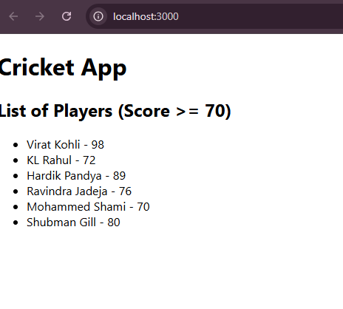

When Flag=false

